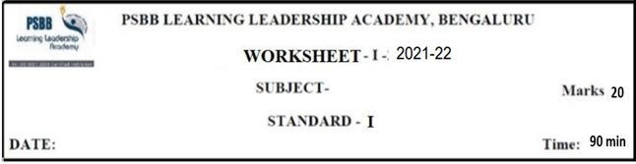
ENGLISH
14.2.22
ONLINE WORKSHEET 5 – 2021-22

I. Number these sentences in the correct order. 6X1/2=3

a. Jijo looks after Elly.
b. Dr. Anand gives Elly some medicines.
c. Mother elephant and father elephant are happy to see Elly.
d. Jijo sees Elly lying in the mud.
e. The keepers take Elly to the camp.
f. Elly gets well and is able to walk and run

II. Complete these sentences. 2X1=2

a. Find a place where you can see ___________________________________.
b. Jijo likes to watch elephants______________________________________.

III. ERC 3X1=3

They looked at the basket and said “Guavas! We like guavas.”

a. Who looked at the basket?
b. Who was carrying the basket?
c. Name the lesson.

IV Answer the following 2X1=2

a. What fruit fell into Champa’s basket?
b. Why was baby elephant crying?

V Choose the correct prepositions using in/on/under 5X1=5

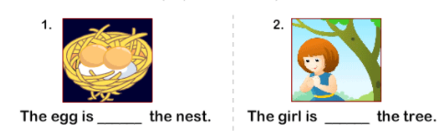

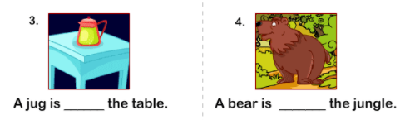

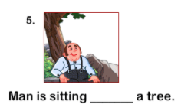

VI . Complete the compound words

- 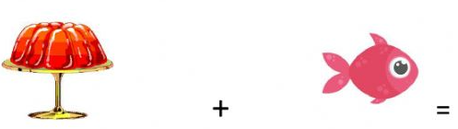

JELLY______

- 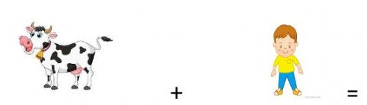

_________BOY

- 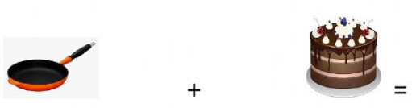

PAN______________

- 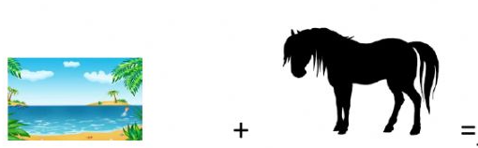

___________HORSE

-

__

- 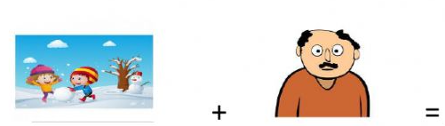

SNOW ______

___________________________________________________________________________________

14.2.22
ENGLISH
ONLINE WORKSHEET 5 – 2021 -22

ANSWER KEY

I. Number these sentences in the correct order. 6X1/2=3

a. Jijo looks after Elly. 4
b. Dr. Anand gives Elly some medicines. 3
c. Mother elephant and father elephant are happy to see Elly. 6
d. Jijo sees Elly lying in the mud. 1
e. The keepers take Elly to the camp. 2
f. Elly gets well and is able to walk and run 5

II. Complete these sentences. 2X1=2

a. Find a place where you can see up and down the road.
b. Jijo likes to watch elephants swing their trunks and play in the mud.

III. ERC 3X1=3

They looked at the basket and said “Guavas! We like guavas.”

a. Who looked at the basket? ---The two parrots
b. Who was carrying the basket? ---- Champa
c. Name the lesson. ----- Champa’s fruit basket.

IV. Answer the following. 2X1=2

a. Oranges fell into Champa’s basket.
b. The baby elephant has hurt her leg and was not able to get up.

V Choose the correct prepositions using in/on/under 5X1=5

UNDER
ON

IN
ON

UNDER

VI . Complete the compound words 5X1=5

1.

JELLYFISH

2.

COWBOY

3

PANCAKE

4

SEAHORSE

5

SNOW MAN

